**Experiment Number – 3**

**Title- Program to print non-prime numbers from the given range using for loop**

**Theory-**

In computer programming, loops are used to repeat a block of code. For example, if we want to show a message **100** times, then we can use a loop. It's just a simple example; you can achieve much more with loops.

There are 2 types of loops in Python:

* for loop
* while loop

In Python, the for loop is used to run a block of code for a certain number of times. It is used to iterate over any sequences such as [list](https://www.programiz.com/python-programming/list), [tuple](https://www.programiz.com/python-programming/tuple), [string](https://www.programiz.com/python-programming/string), etc.

The syntax of the for loop is:

**for val in sequence:**

**statement(s)**

Here, val accesses each item of sequence on each iteration. Loop continues until we reach the last item in the sequence. The for loop does not require an indexing variable to set beforehand.

The flow chart of for loop is shown below.

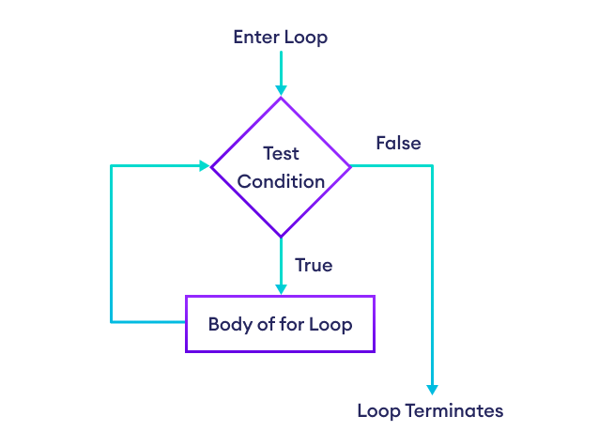

## The break Statement

With the break statement we can stop the loop before it has looped through all the items:

## The continue Statement

With the continue statement we can stop the current iteration of the loop, and continue with the next:

### ****Pass Statement****

We use [pass statemen](https://www.geeksforgeeks.org/python-pass-statement/)t in Python to write empty loops. Pass is also used for empty control statements, functions and classes.

## The range() Function

To loop through a set of code a specified number of times, we can use the range() function, The range() function returns a sequence of numbers, starting from 0 by default, and increments by 1 (by default), and ends at a specified number.

for x in range(6):  
  print(x)

The above code displays numbers from 0 to 5.

## Python for loop with else

A for loop can have an optional else block as well. The else part is executed when the loop is finished. For example,

For example

for i in range(6):

print(i, end=",")

else:

print("\nNumbers from 0 to 5 are displayed")

The output of the above program is -

0,1,2,3,4,5,

Numbers from 0 to 5 are displayed

## ****Nested Loops****

Python programming language allows to use one loop inside another loop. Following section shows few examples to illustrate the concept.

**Syntax:**

for val in sequence:

for val in sequence:

statements(s)

statements(s)

Exercise –

1. [Write a program to display all prime numbers within a range](https://pynative.com/python-if-else-and-for-loop-exercise-with-solutions/#h-exercise-11-write-a-program-to-display-all-prime-numbers-within-a-range)
2. [Write a program to Display Fibonacci series up to 10 terms](https://pynative.com/python-if-else-and-for-loop-exercise-with-solutions/#h-exercise-12-display-fibonacci-series-up-to-10-terms)
3. [Write a program to Find the factorial of a given number](https://pynative.com/python-if-else-and-for-loop-exercise-with-solutions/#h-exercise-13-find-the-factorial-of-a-given-number)
4. Write a Python program that prints all the numbers from 0 to 9 except 3 and 6.
5. Write a Python program that iterates the integers from 1 to 50. For multiples of three print "Fizz" instead of the number and for multiples of five print "Buzz". For numbers that are multiples of three and five, print "FizzBuzz".